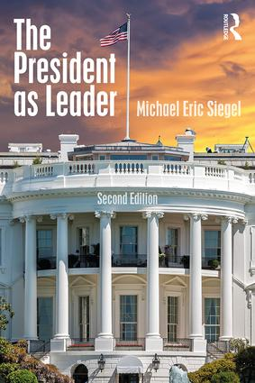
Leadership Lessons from the White House

Michael Eric Siegel, Ph.D.

Consider how the four dimensions presidential leadership apply to your own challenges as a manager or future manager/leader.

Policy (Vision)

Why am I running (did I run) for office?
What is my purpose?
Where do I want to lead the nation?
What do I want to accomplish during the next 4 years?
How will my administration make a difference in the lives of US citizens?
What do I want my legacy to be?

Consider these questions as they relate to policy (vision).

________________________________________________________________________________________________________________________________________________________________________________________________________________________________________________________________________________________________________________________________________________________________________
____________________________________________________________________________________________________________________________________________________________________________________

Politics (Strategy, Political Savvy)

How will I implement or execute my vision?
Whose help do I need to execute my vision?
What strategies will I use to influence my own political party or the other political party?
How will I exert influence or negotiate for change?
How many issues will I tackle at one time?

Consider these questions as they relate to politics (strategy, political savvy).

________________________________________________________________________________________________________________________________________________________________________________________________________________________________________________________________________________________________________________________________________________________________________
____________________________________________________________________________________________________________________________________________________________________________________

Leadership Lessons from the White House
to the Courthouse (cont’d)
Michael Eric Siegel, Ph.D.

Structure (Management - Organization)

How will I organize the White House?
What management structure will I use?
Will I have a chief-of-staff?
Will I maintain an open or closed operation?
Will I favor micro or macro management of White House staff (direct reports)?
How will I assure the alignment of the management with my policy agenda?

Consider these questions as they relate to structure (management - organization).

________________________________________________________________________________________________________________________________________________________________________________________________________________________________________________________________________________________________________________________________________________________________________
____________________________________________________________________________________________________________________________________________________________________________________

Process (Decision Making)

How will I make and announce decision?
Will I deliberately encourage dissenting opinions?
How will I handle conflict among my staff, or direct reports?
How will I apply “damage control” when needed?
How will I handle a crisis?

Consider these questions as they relate to process (decision making).

________________________________________________________________________________________________________________________________________________________________________________________________________________________________________________________________________________________________________________________________________________________________________
____________________________________________________________________________________________________________________________________________________________________________________

